Suffuron Bridge
  - Unreal Tournament Capture the Flag map
  - By Harrison Baumann
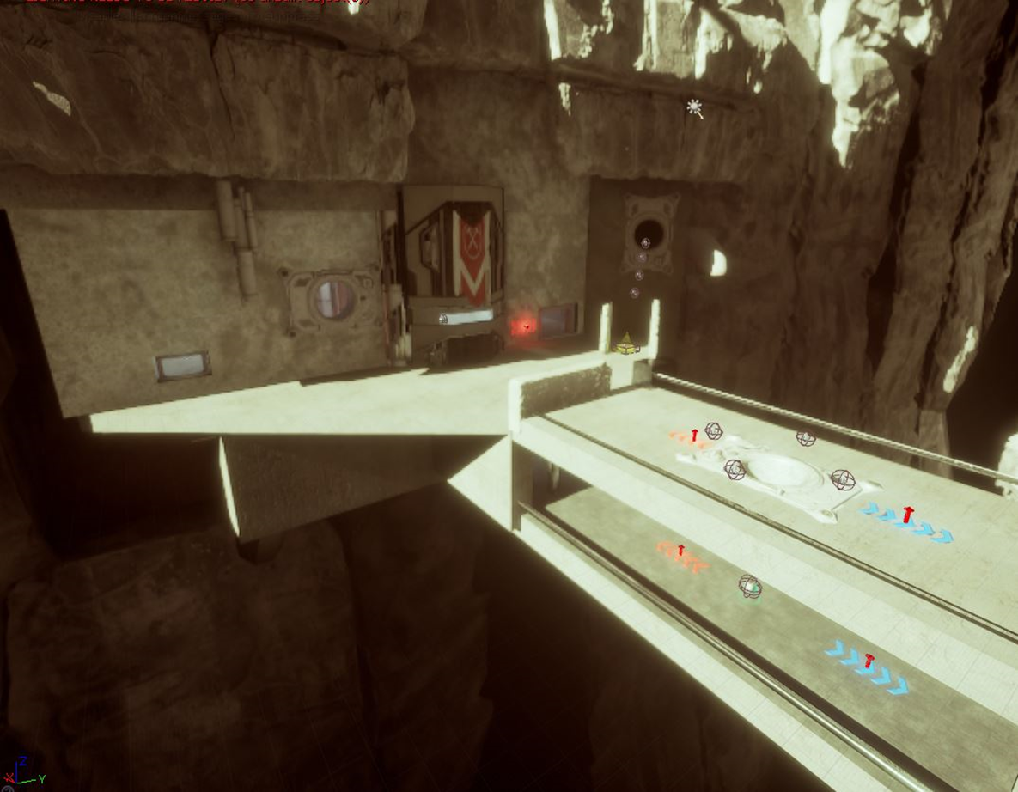
VS.0.2
Change Log
Date | Requestor | VS | Change
1/28/2019 | Professor Porter, Professor Luna | 0.1 | Initial Document
1/30/2019 | Harrison Baumann | 0.2 | Added updated gameplay maps, map descriptions and needed elements, gameplay elements, metrics, overview summery edited.

Table of Contents
Overview 3
Map 3
Summary 3
Metrics 3
Hook(s) 3
Schedule 3
Gameplay 4
Detailed area map for the bases 4
Area Description 4
Requirements 5
Flow map for the bases 5
Area Description 5
Detail map for the lower tunnel 6
Area Description 6
Flow map for the lower tunnel 7
Area Description 7
Detail map for the upper tunnel 8
Area Description 8
Requirements 8
Flow map for the Upper Tunnel 9
Area Description 9
Requirements 9
Base side view 10
Area Description 10
Aesthetics 10
General Thematic Elements 10
Special Thematic Elements 10
Lighting 10
Visual References 12
References 15

Overview

Map
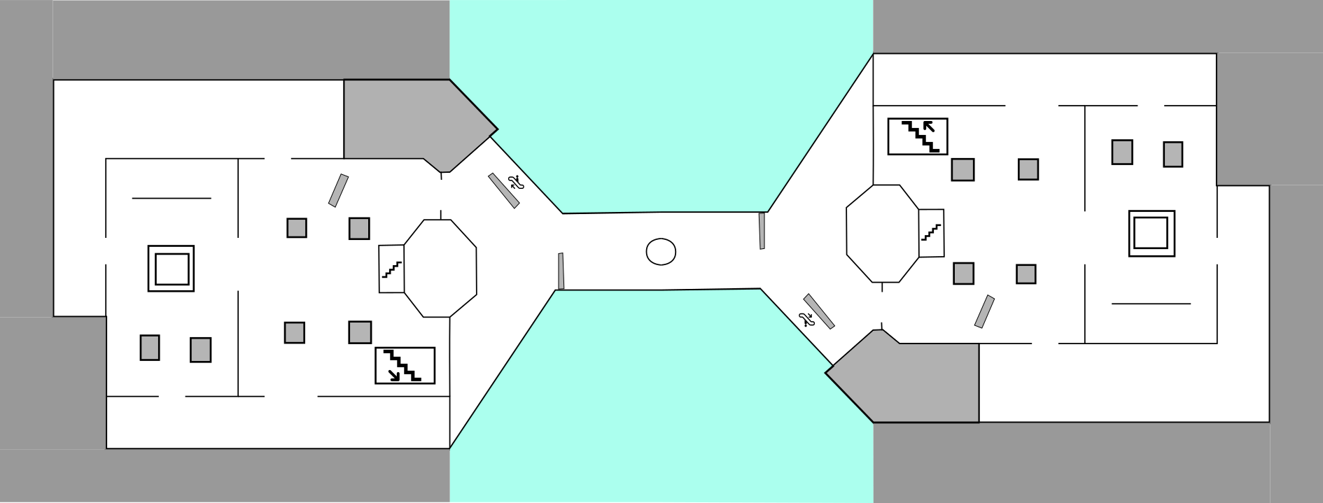

Summary
Supply Bridge is a multiplayer capture the flag level built for Unreal Tournament 4. Two teams will battle for supremacy over a deep desert canyon on an unnamed planet outside of the main shipping lanes of Liandri. The design of the bases allows for intense easy in, hard out gameplay. The short distance between the bases forces the teams to be very conscience of routes because of the short time from flag to flag. Inside the bases are close range spaces that highlight the flak cannon and rocket launcher. The mid is constructed with the link gun and stinger minigun in mind with open sightline and larger spaces. The bottom of the canyon is far below and will result in player death if they fall of the bridge.

Metrics
- 5000 Cm x cm 16000

Hook(s)
- Upper level pipes lead to the flag room making for exciting flag runs.
- Great visuals in the canyon draws the player into the world.

Schedule
Date | Milestone | Requirement
10/11/2017 | Grey Box Complete | Block out the entire level in  gray box
17/11/2017 | Gameplay Complete | Grey box is locked with gameplay elements locked  Meshes are locked in  Lighting is locked
25/11/2017 | Mesh Complete | Map is gameplay, Mesh
25/11/2017 | Lighting Complete | Lighting complete and all post-processing volumes finalized
7/12/2017 | RTM

Gameplay
- Armor base x 2
- Health medium x 3
- Health Vial x 20
- Base flags x 2
- Jump pads x 2
- Player starts x 18
- Rocket Launcher x 2
- Flak Cannon x 2
- Link gun x 2
- Stinger Minigun x 2
- Ammo x 2 beside every weapon

Detailed area map for the bases
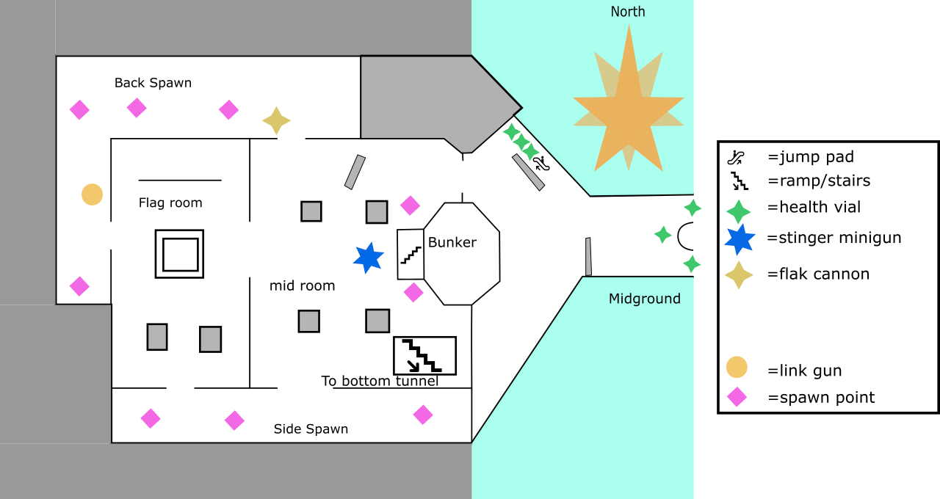

Area Description
The main base is intended to be the focus of the combat spaces in this map. The combat requires a mix of medium and short-range weapons with the Flak cannon, link gun being in the back of the base, and the stinger minigun and the rocket launcher being closer to the midground for ranged combat. There is one large armor to bolster the defenders of the flag.

Requirements
One broken pipe asset is need for this area.

Flow map for the bases
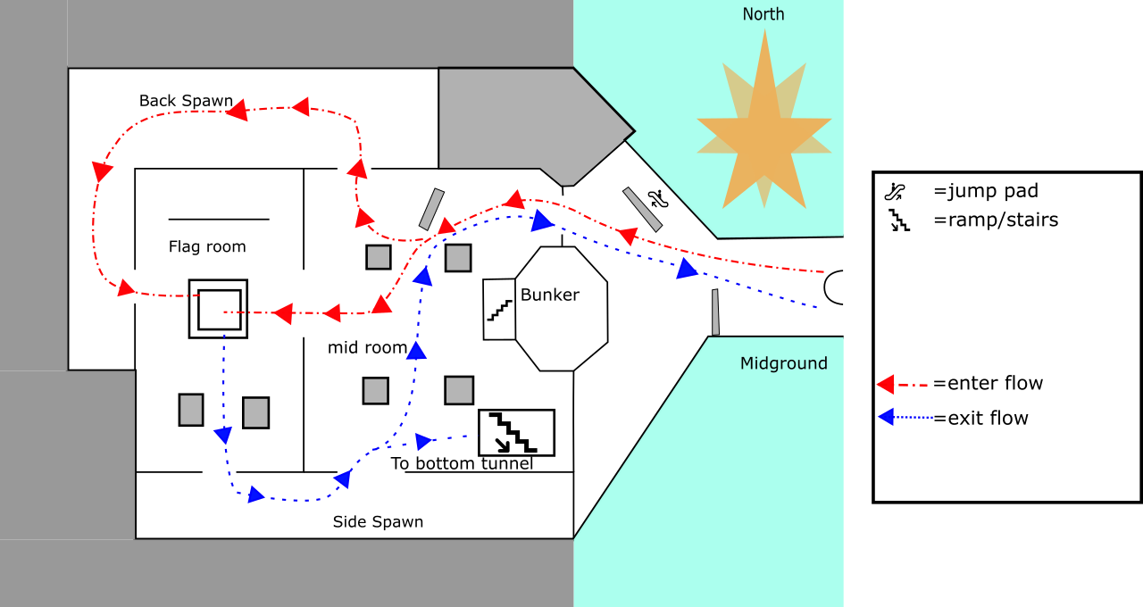

Area Description
The main base is intended to be the focus of the combat spaces in this map. It is easy to get into the flag room from the upper pipes and through the tunnel in the floor. The flag is on a raised platform as well. There are four ways into the base but only two ways out with the flag.

Detail map for the lower tunnel
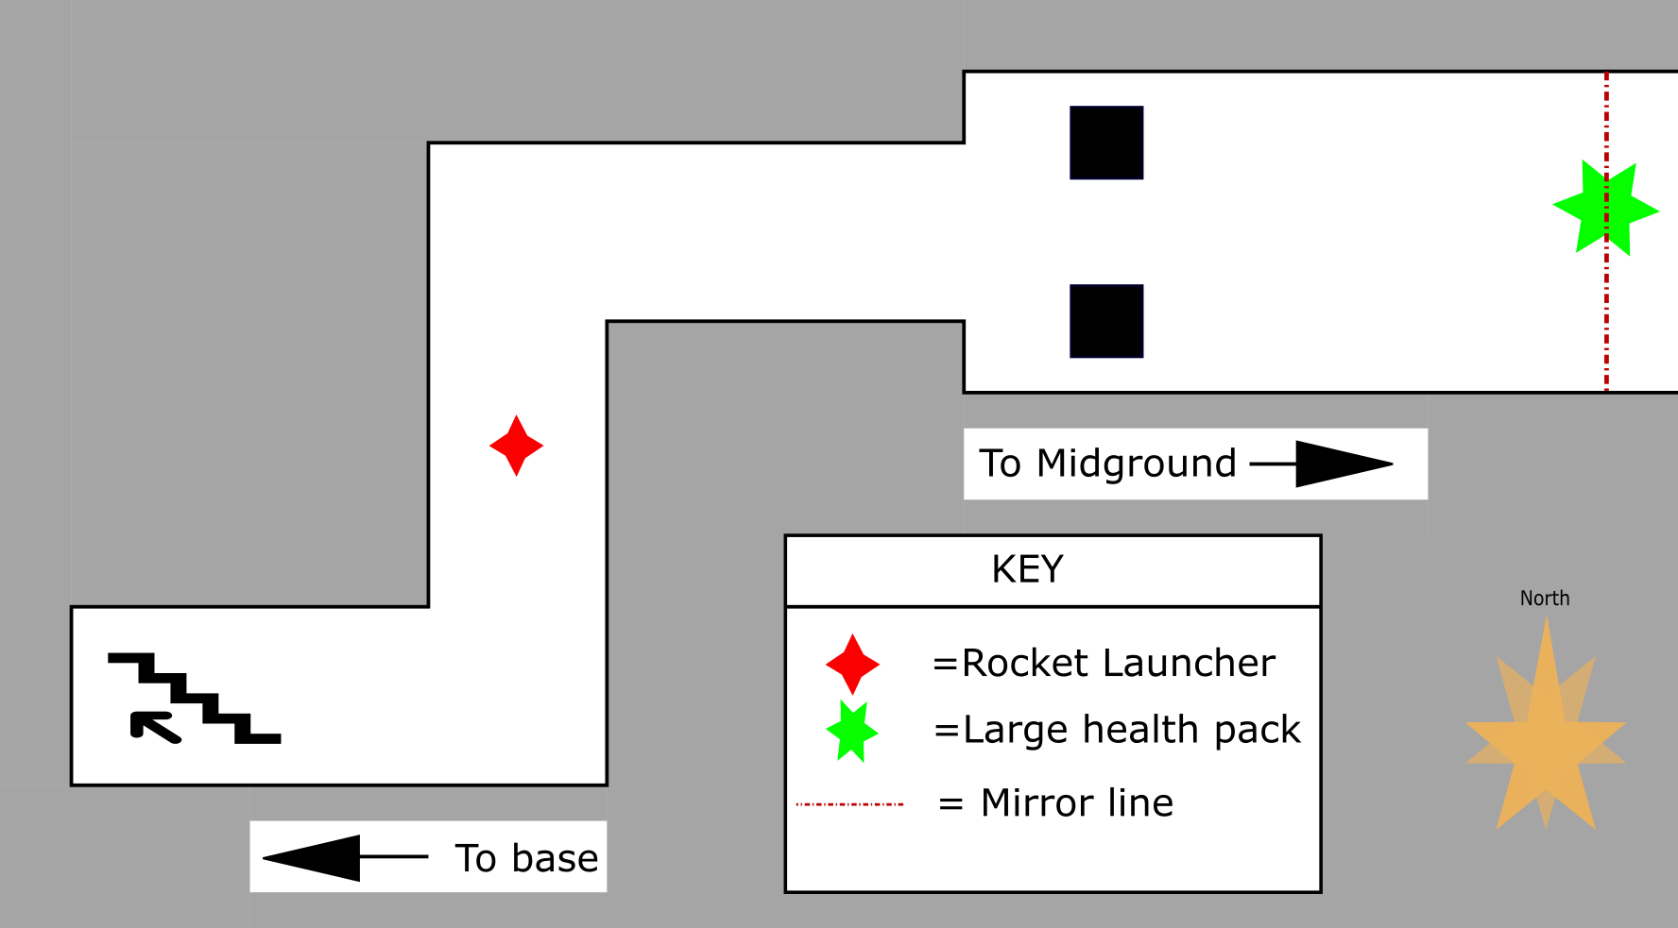

Area Description
The under tunnel provides a secondary combat space for the mid ground. This area features the rocket launcher and a large health pack. This area is accessible from the base interior via ramps and a hole in the bridge that drops the player to the middle of the under tunnel.

Flow map for the lower tunnel
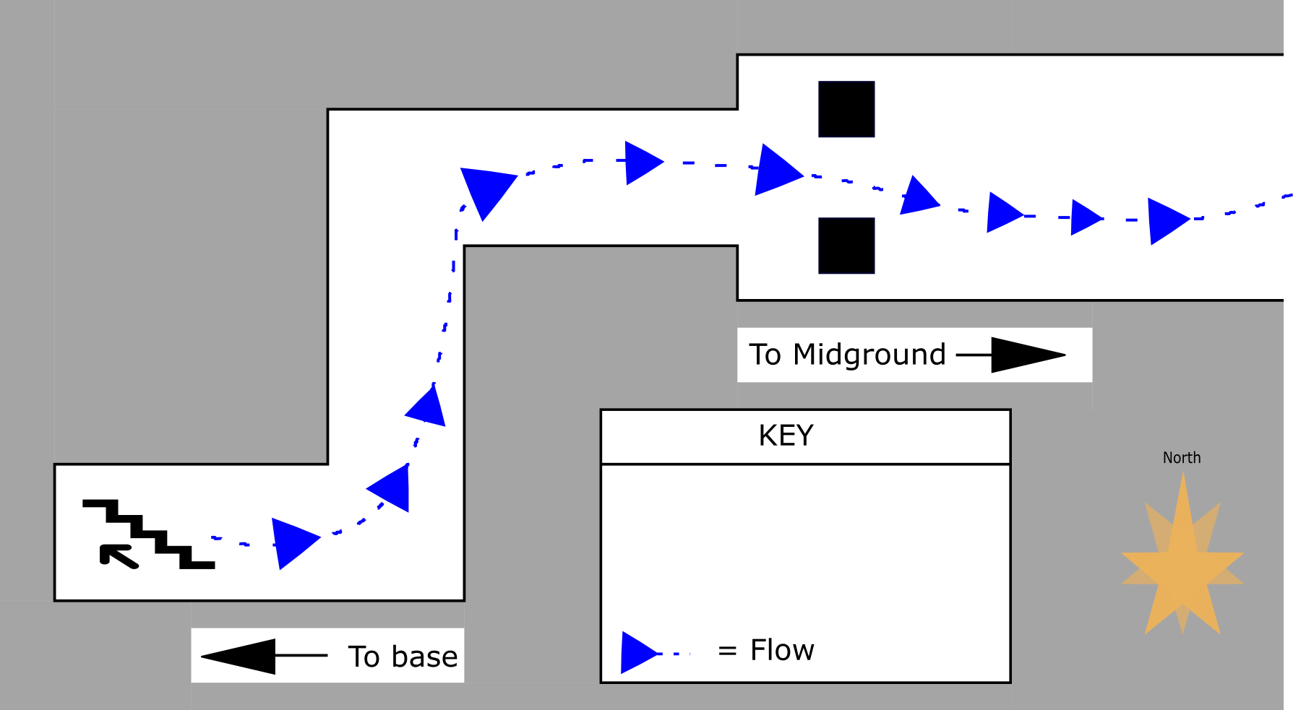

Area Description
The exiting flag runner can use this path to avoid crossing the top of the bridge and pick up a large health pack on the way back to the their base for a flag capture

Detail map for the upper tunnel
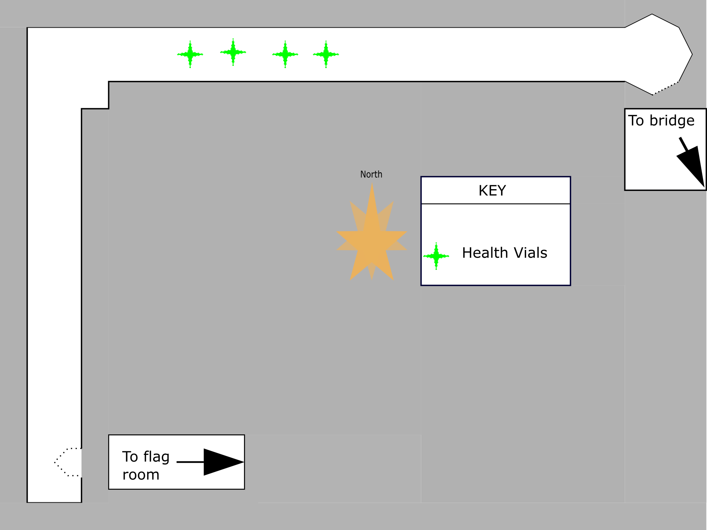

Area Description
This is intended to be a secondary pathway to the flag room and a overwatch defensive point with a small pool of replenishing health packs nearby. The aesthetic of the area is a pipes and maintenance area with some demonic writing on the walls.

Requirements
One broken pipe asset is needed for this area.

Flow map for the Upper Tunnel
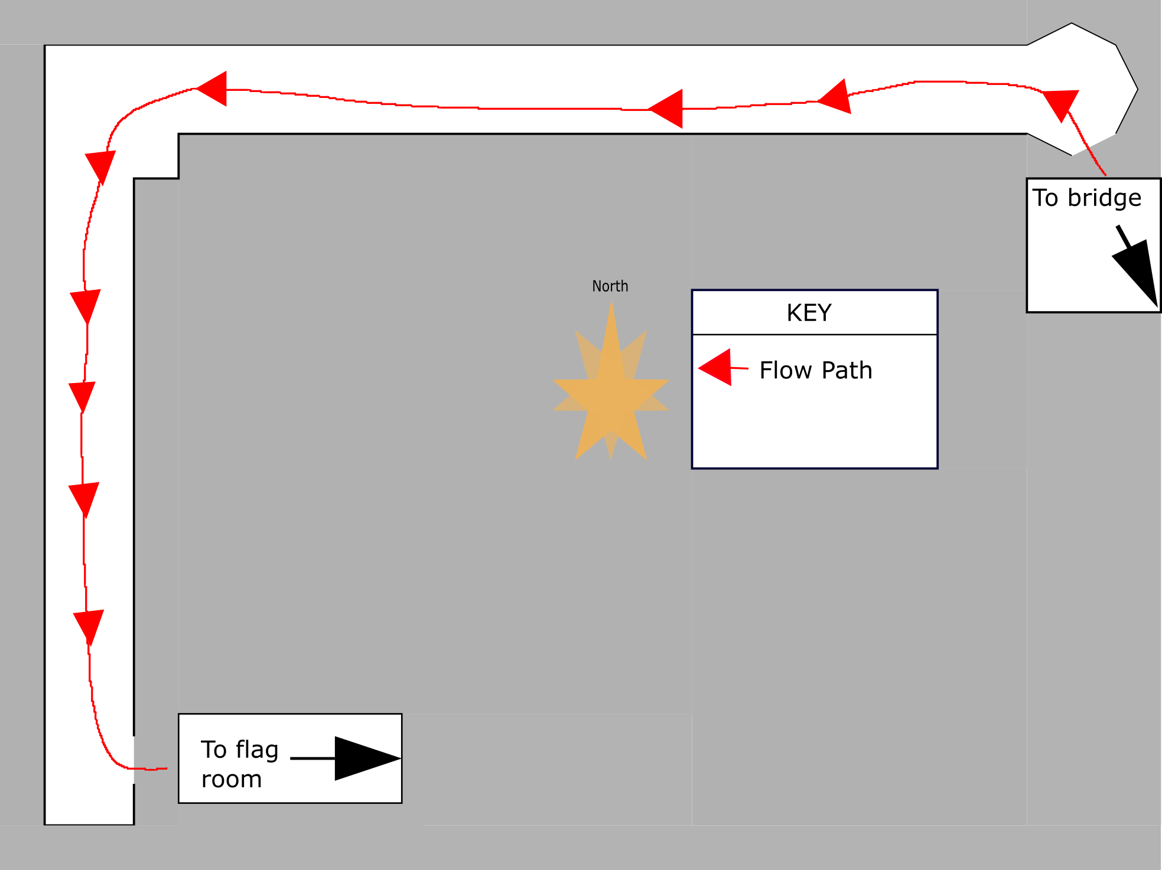

Area Description
This upper area is intended to be a flow option for the attacking team to sneak into the opposing teams flag room but not provide a easy escape as the player cannot get back up to this area with the flag without going back through to the front of the base.

Requirements
One broken pipe asset is need for this area.

Base side view
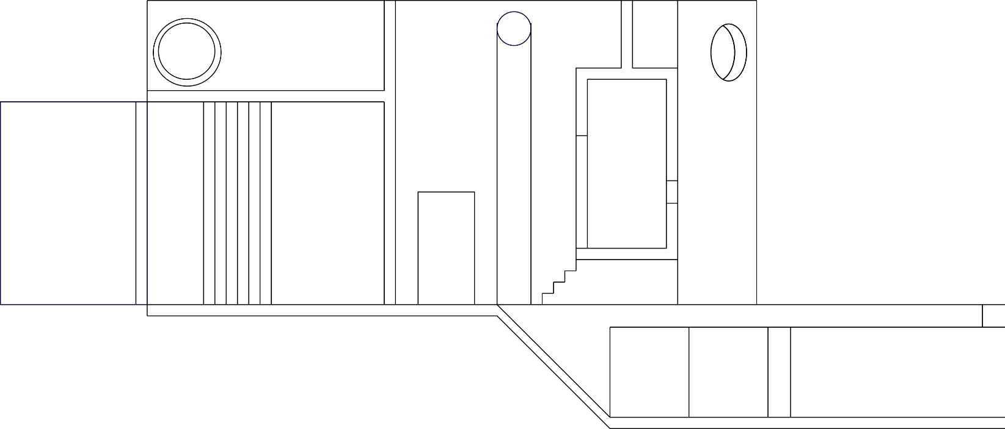

Area Description
Here is a side view from the side spawn area to help with elevations.

Aesthetics

General Thematic Elements
- The map takes place in a desert canyon and industrial style bases.
- The atmospheric visibility is clear but with heat waves present outside the bases.

Special Thematic Elements
- Large canyon walls and large chains that give a sense of scale to the player.
- Crazy glowing cult script in the upper tunnels.

Lighting
- Industrial lighting
- The lighting outside is late afternoon that allows for deeper shadows.
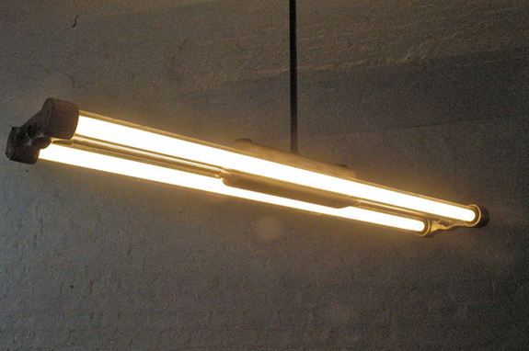
[1]
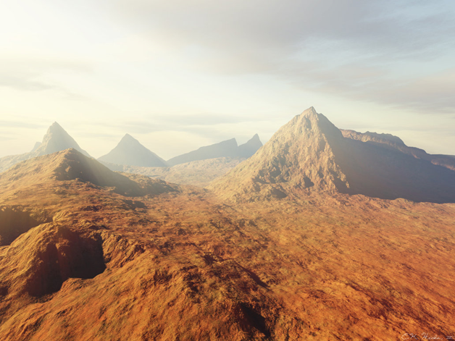
[2]
The intent is to achieve this style of atmosphere for the outside elements of the map with the fog and implied heat.
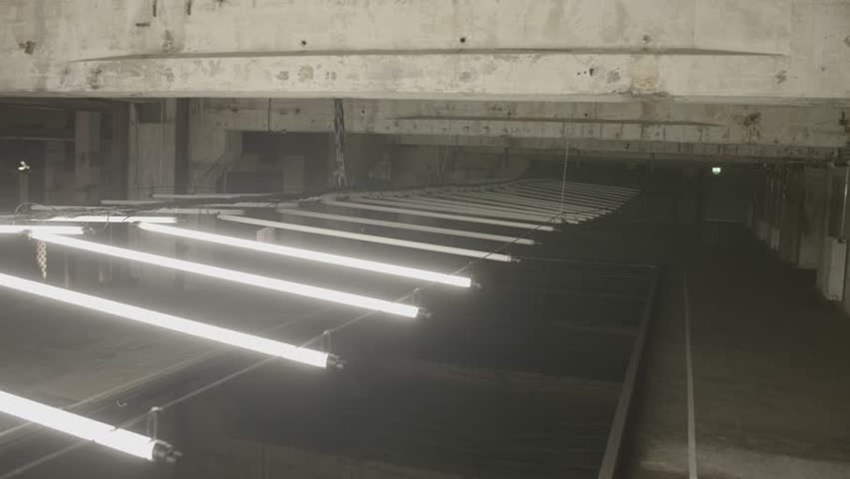
[3]
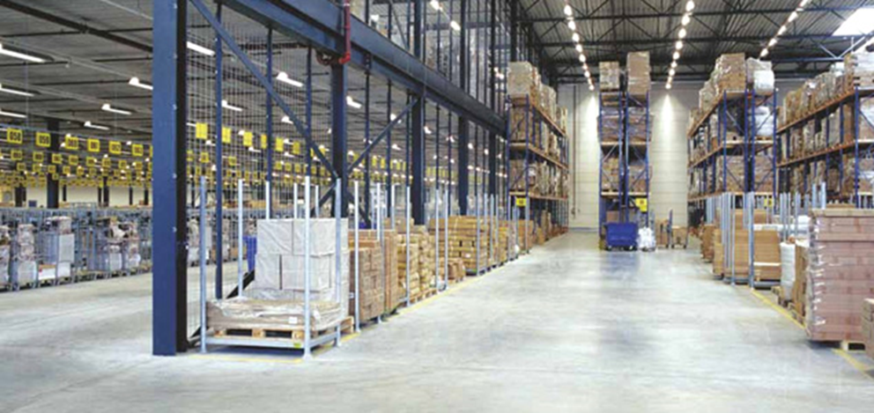
[4]

Visual References
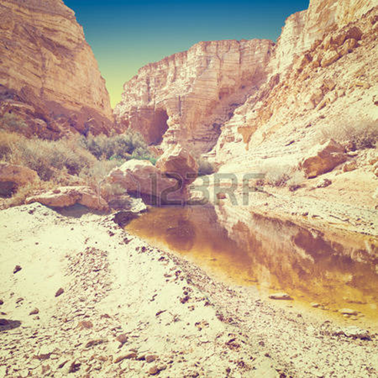
[5]
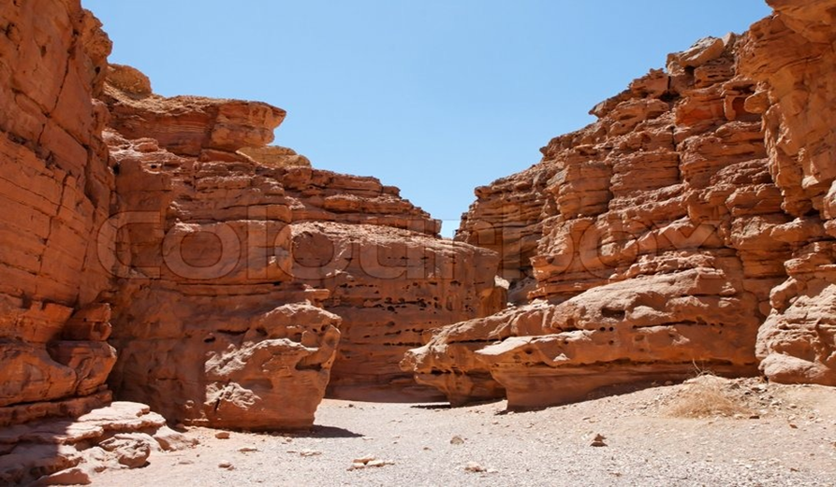
[6]
The sides of the canyon will resemble these rocky canyons
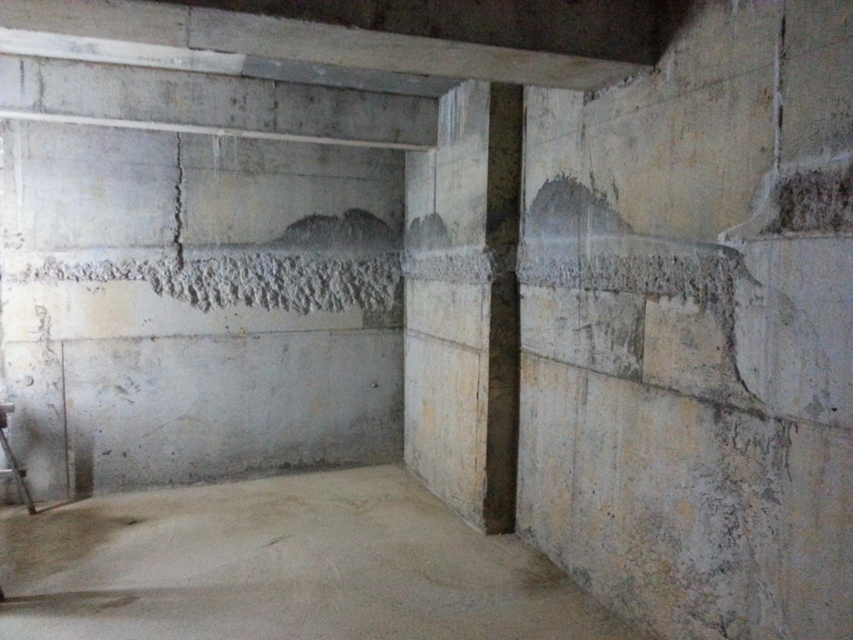
[7]
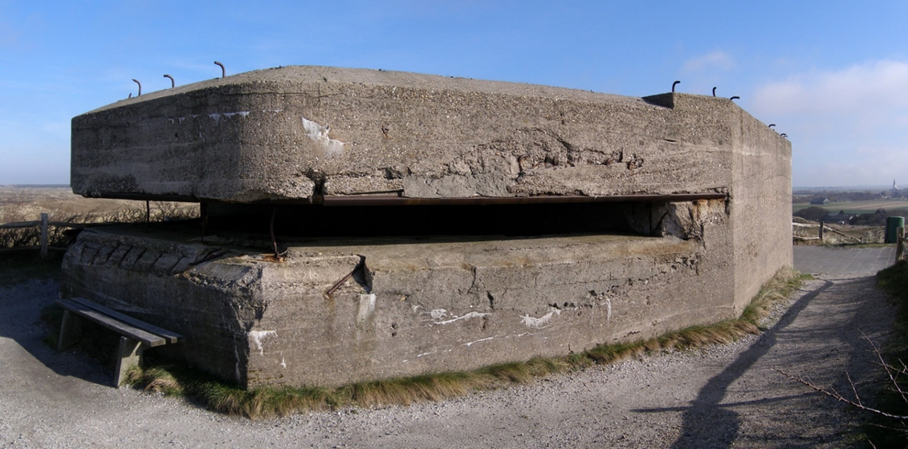
[8]
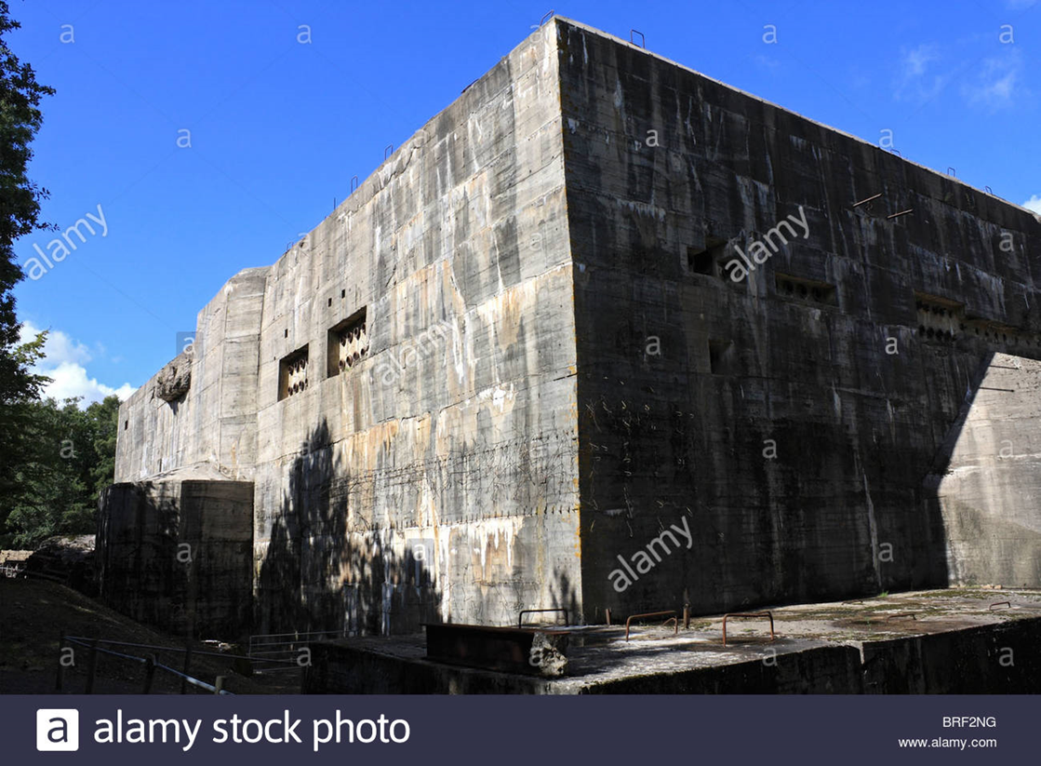
[9]

References
[1] https://www.google.com/imgres?imgurl=https%3A%2F%2Fs-media-cache-ak0.pinimg.com%2Foriginals%2Fe1%2F78%2F11%2Fe17811152998063e4b68a37aa89a0123.jpg&imgrefurl=https%3A%2F%2Fwww.pinterest.com%2Fpin%2F456130268482493828%2F&docid=YanzrZHnGeIbAM&tbnid=VdkcqEiSXs9eLM%3A&vet=10ahUKEwizyL62983XAhWk34MKHTSpCxEQMwjJASgLMAs..i&w=768&h=510&bih=974&biw=1920&q=fluorescent%20industrial%20&ved=0ahUKEwizyL62983XAhWk34MKHTSpCxEQMwjJASgLMAs&iact=mrc&uact=8
[2] https://dveditor.deviantart.com/art/Desert-Afternoon-27795726
[3] https://www.shutterstock.com/video/clip-31374850-stock-footage-slow-motion-shot-of-white-fluorescent-lighting-turn-on-and-off-in-the-dark-in-industrial-building.html
[4] https://www.relumination.com/3-industrial-led-lighting-advantages-incandescent-fluorescent-bulbs/
[5] https://www.colourbox.com/image/desert-landscape-of-weatherd-red-rocks-in-red-canyon-israel-image-3321738
[6] https://www.123rf.com/photo_57602787_canyon-en-avedat-of-the-negev-desert-in-israel-at-sunset.html
[7] http://www.avsforum.com/forum/19-dedicated-theater-design-construction/1482805-coolgeek-s-concrete-bunker-home-theater-build.html
[8] https://commons.wikimedia.org/wiki/File:PanoBunker.jpg
[9] http://www.alamy.com/stock-photo-the-blockhaus-at-eperlecques-a-giant-concrete-bunker-is-the-v2-launch-31678908.html

